Setting Up the Parametric CAD Model

1. Open the CATIA Model “\AEV-Tool\Git\AEV_Tool\07_CAD\ SRT_2030.CATProduct”
2. Go to File > Save Management as shown in the picture

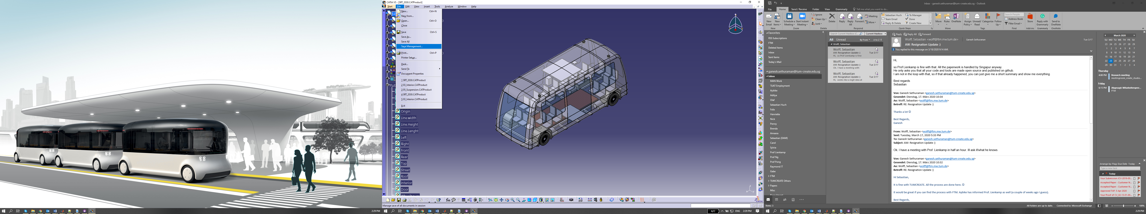

1. Press the save as button as shown in the picture

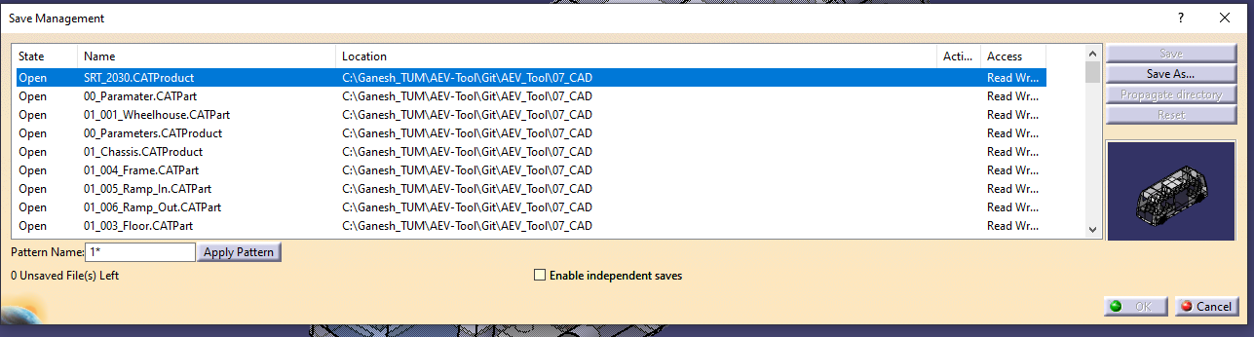

1. Save it in the same location by overwriting the file as shown

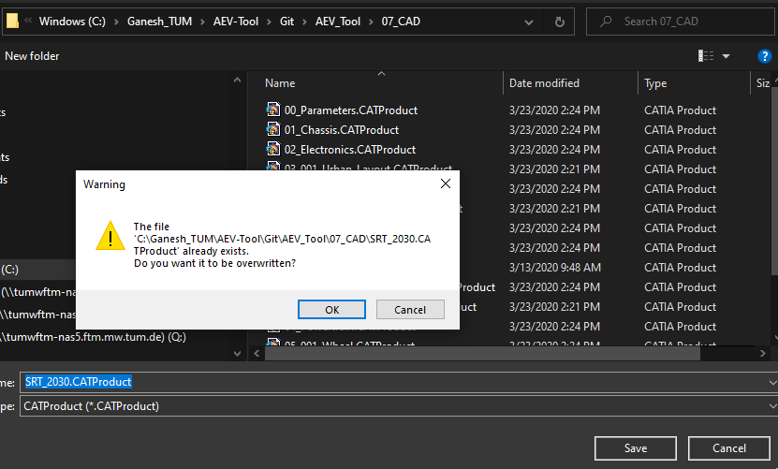

1. Press the “Propagate Directory” as shown in the image. Save by overwriting all the files and click the ‘Ok’ Button.

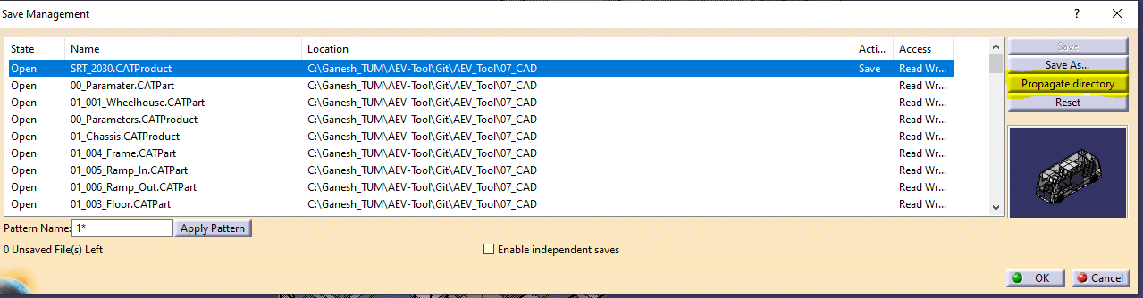

1. Go to ‘Edit’ > ‘Links’ as shown in the image

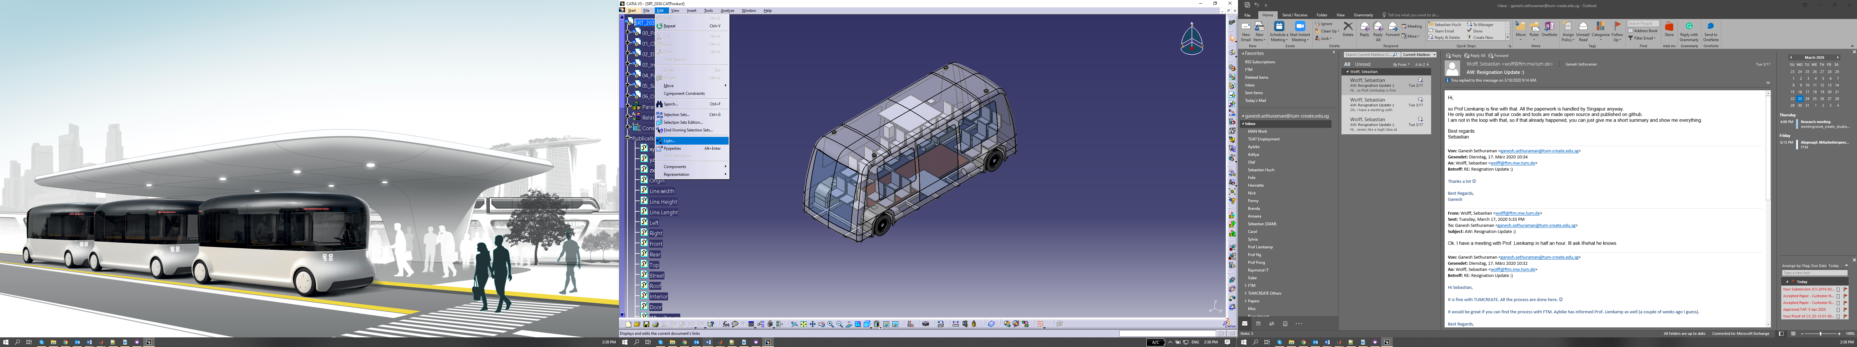

1. Press the ‘Replace’ button as shown in the picture

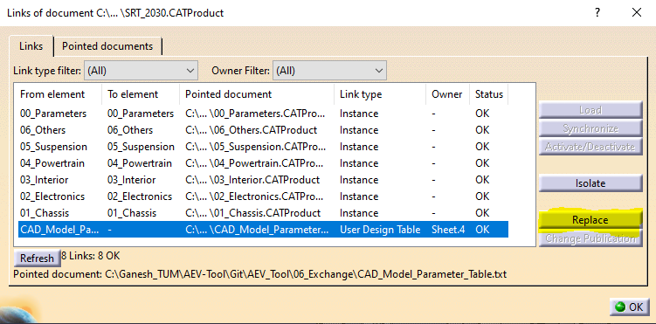

1. Change it to

“\AEV-Tool\Git\AEV_Tool\06_Exchange\CAD_Model_Parameter_Table.txt” as shown and press the ‘ok’ button.

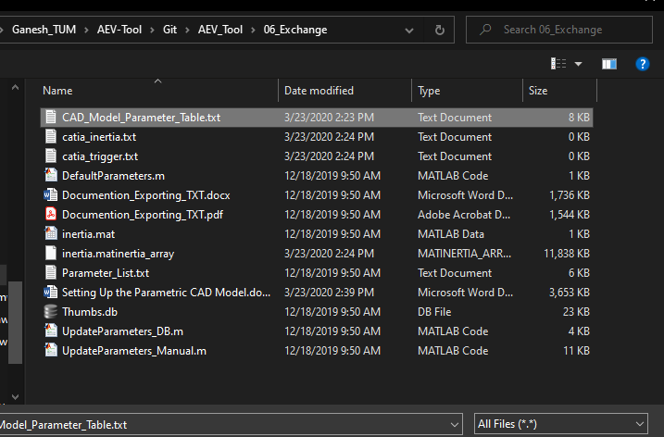

1. Save the CAD Model